Chapter 13, Problem 77.

The three-phase system of a town distributes power with a line voltage of 13.2 kV. A pole transformer connected to single wire and ground steps down the high-voltage wire to 120 V rms and serves a house as shown in Fig. 13.138.

(a) Calculate the turns ratio of the pole transformer to get 120 V.

(b) Determine how much current a 100-W lamp connected to the 120-V hot line draws from the high-voltage line.

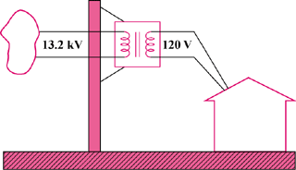

Figure 13.138
For Prob. 13.77.

